EXPT NO: 6 | IMPLEMENTATION OF LONG SHORT-TERM MEMORY (LSTM) FOR SENTIMENT ANALYSIS
DATE: 11-10-2026

PRE-LAB QUESTIONS (PROVIDE BRIEF ANSWERS TO THE FOLLOWING QUESTIONS)

- Explain the working of Long Short-Term Memory (LSTM) networks in processing sequential data.

LSTM is a type of Recurrent Neural Network (RNN) that processes sequential data and remembers important information for a long time. It uses memory cells and gates to decide which information to store, forget, and output.

- Discuss why is LSTM considered suitable for sentiment analysis of textual data?

LSTM can understand the order of words and learn long-term dependencies in sentences. It helps identify whether a review expresses positive or negative sentiment by understanding its context.

- Explain the role of memory cells and gates in an LSTM network.

Memory cells store important information from previous steps. The input, forget, and output gates control what information is added, removed, and passed to the next step.

- Explain the importance of tokenization during text preprocessing for sentiment analysis.

Tokenization divides text into smaller units, such as words or tokens. It helps the model process reviews systematically and convert them into numerical sequences.

- Why should textual data be converted into numerical representations before training an LSTM model?
LSTM models perform mathematical operations on numerical data. Therefore, words are converted into numerical values so that the model can learn patterns and classify sentiment.

AIM
To implement a Long Short-Term Memory (LSTM) neural network for sentiment analysis and classify textual data into appropriate sentiment categories based on the learned linguistic patterns.

SOFTWARE REQUIREMENTS
- Python
- TensorFlow / Keras / PyTorch
- Google Colab
- GitHub
- NumPy
- Matplotlib
- Pandas

OBJECTIVES
Students will be able to:
- Understand the architecture and working of Long Short-Term Memory (LSTM) networks.
- Understand the role of LSTM in processing sequential textual data.
- Perform text preprocessing techniques for sentiment classification.
- Convert textual data into numerical sequences suitable for LSTM models.
- Build and train an LSTM-based sentiment classification model.
- Evaluate the performance of the trained LSTM using appropriate classification metrics.
- Analyze the effectiveness of LSTM in learning contextual and sequential patterns from textual data.

PROCEDURE
PART A: DATASET PREPARATION
Perform the following tasks:
- Load a suitable sentiment analysis dataset such as the IMDB Movie Reviews dataset.
- Explore the dataset and examine sample reviews and their corresponding sentiment labels.
- Identify the positive and negative sentiment classes.
- Perform basic text preprocessing such as converting text to lowercase, if required.
- Remove unnecessary characters or symbols, if required.
- Tokenize the reviews into words.
- Build a vocabulary and assign unique integer indices to words.
- Convert the text reviews into numerical sequences.
- Apply sequence padding to obtain inputs of equal length.
- Split the prepared dataset into training and validation/testing datasets.

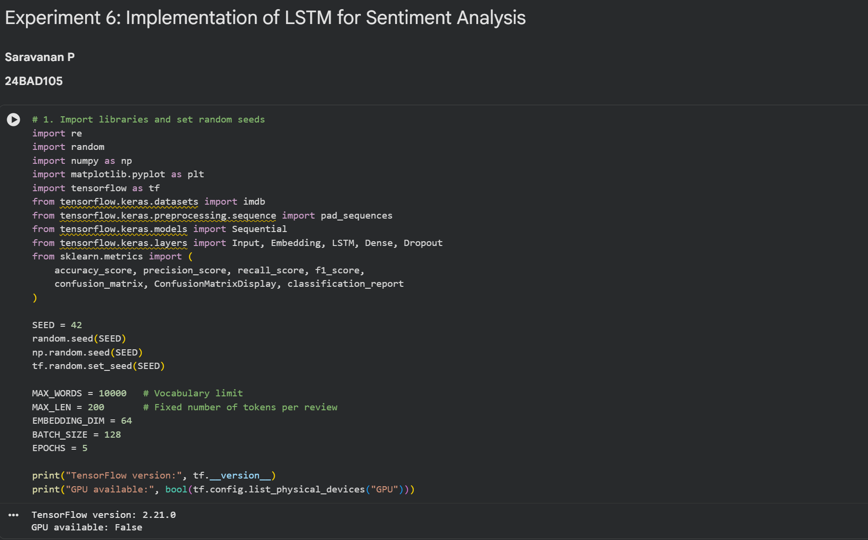

PART B: IMPLEMENTING THE LSTM MODEL
Perform the following tasks:
- Create an Embedding layer to convert words into dense vector representations.
- Add an LSTM layer to learn long-term sequential dependencies in the reviews.
- Add a Dense output layer for sentiment classification.
- Use an appropriate activation function such as Sigmoid for binary sentiment classification.
- Compile the model using an appropriate optimizer and loss function.
- Display the model architecture and model summary.

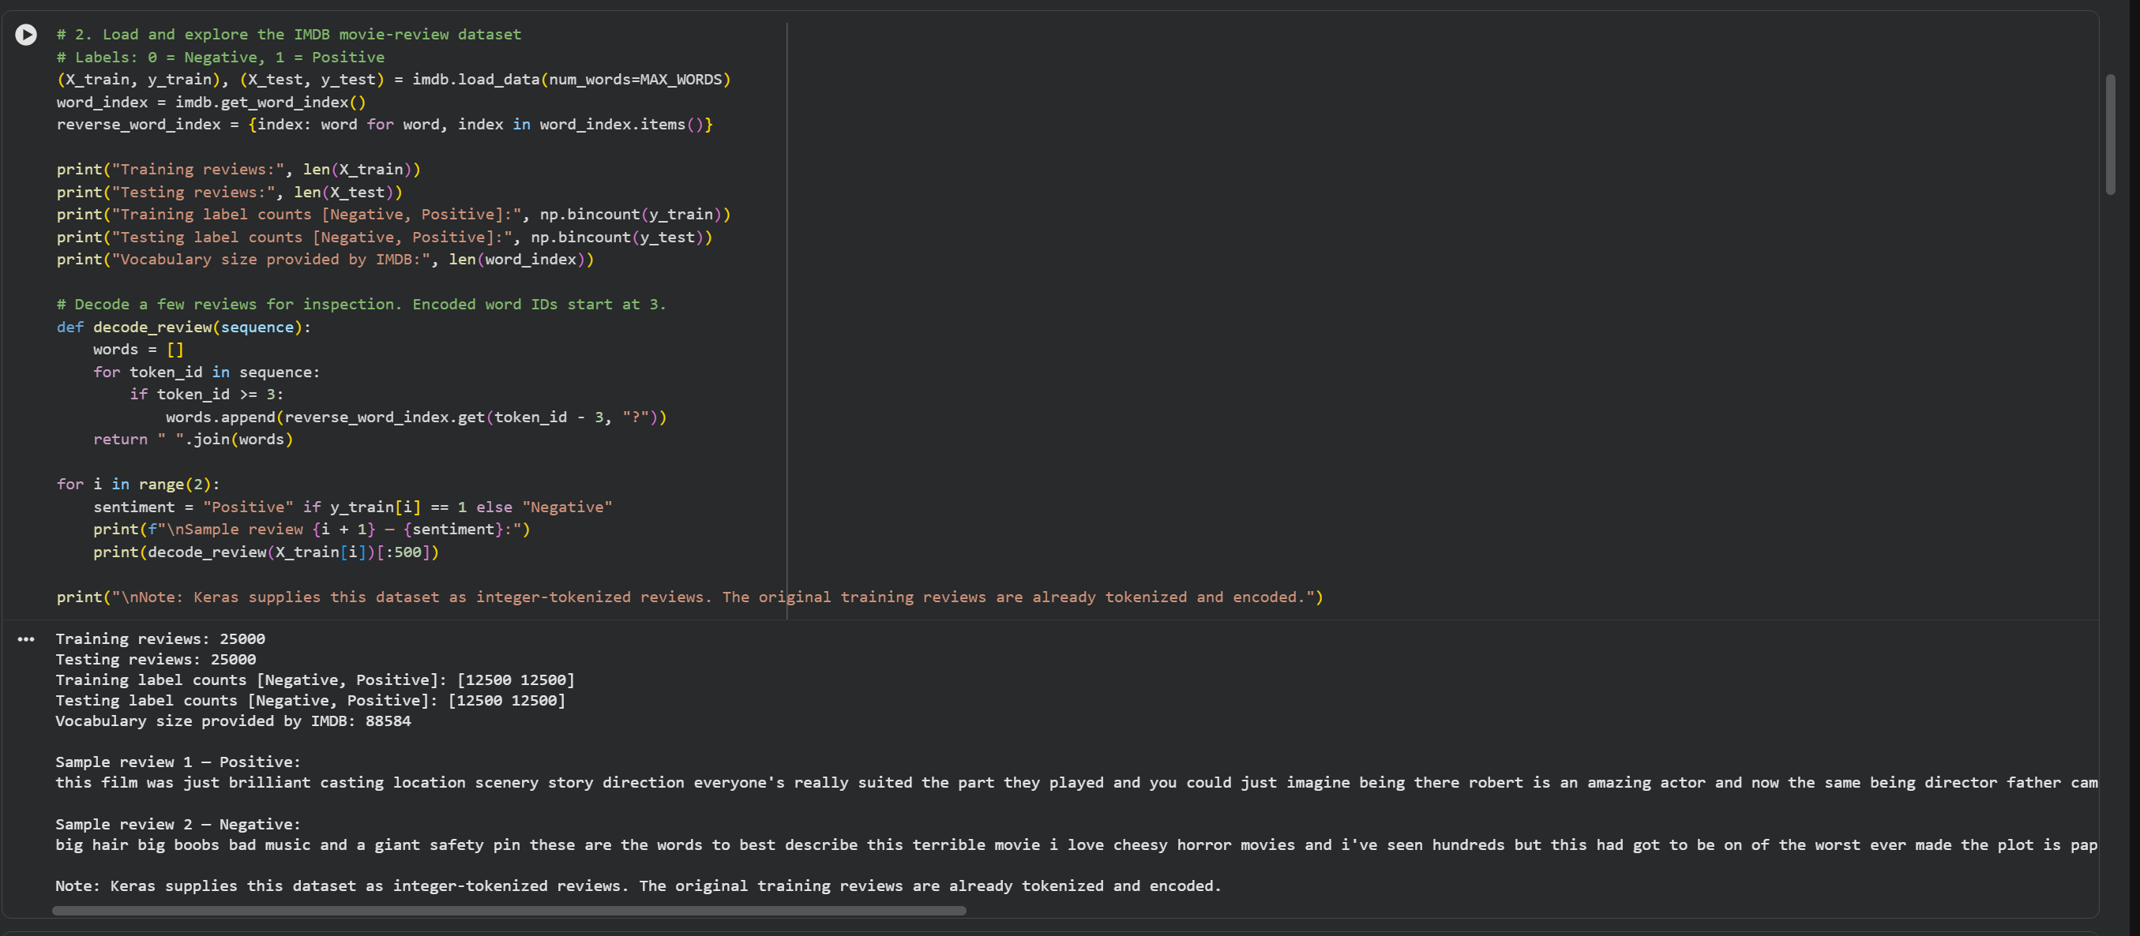

PART C: MODEL TRAINING AND PERFORMANCE EVALUATION
Perform the following tasks:
- Train the LSTM model using the prepared training dataset.
- Validate the model using the validation dataset.
- Record:
  - Training accuracy
  - Validation accuracy
  - Training loss
  - Validation loss
- Evaluate the trained model on the test dataset.
- Calculate suitable evaluation metrics such as:
  - Accuracy
  - Precision
  - Recall
  - F1-score
- Generate a confusion matrix to analyze the classification performance.
- Visualize:
  - Accuracy vs. Epoch
  - Loss vs. Epoch

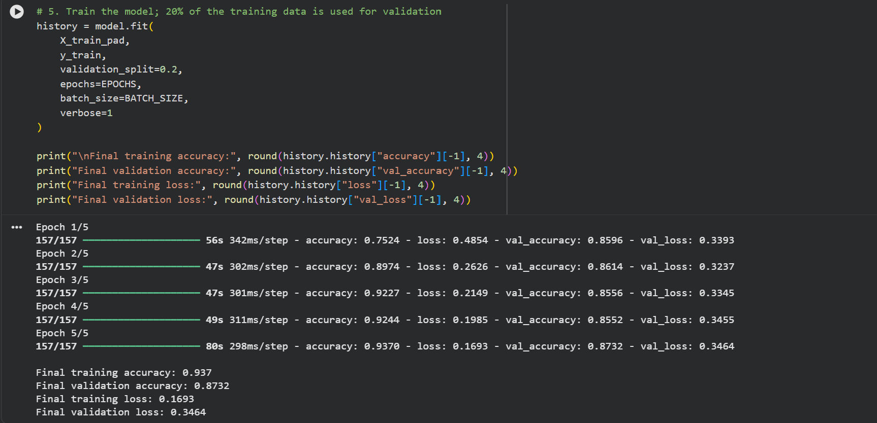

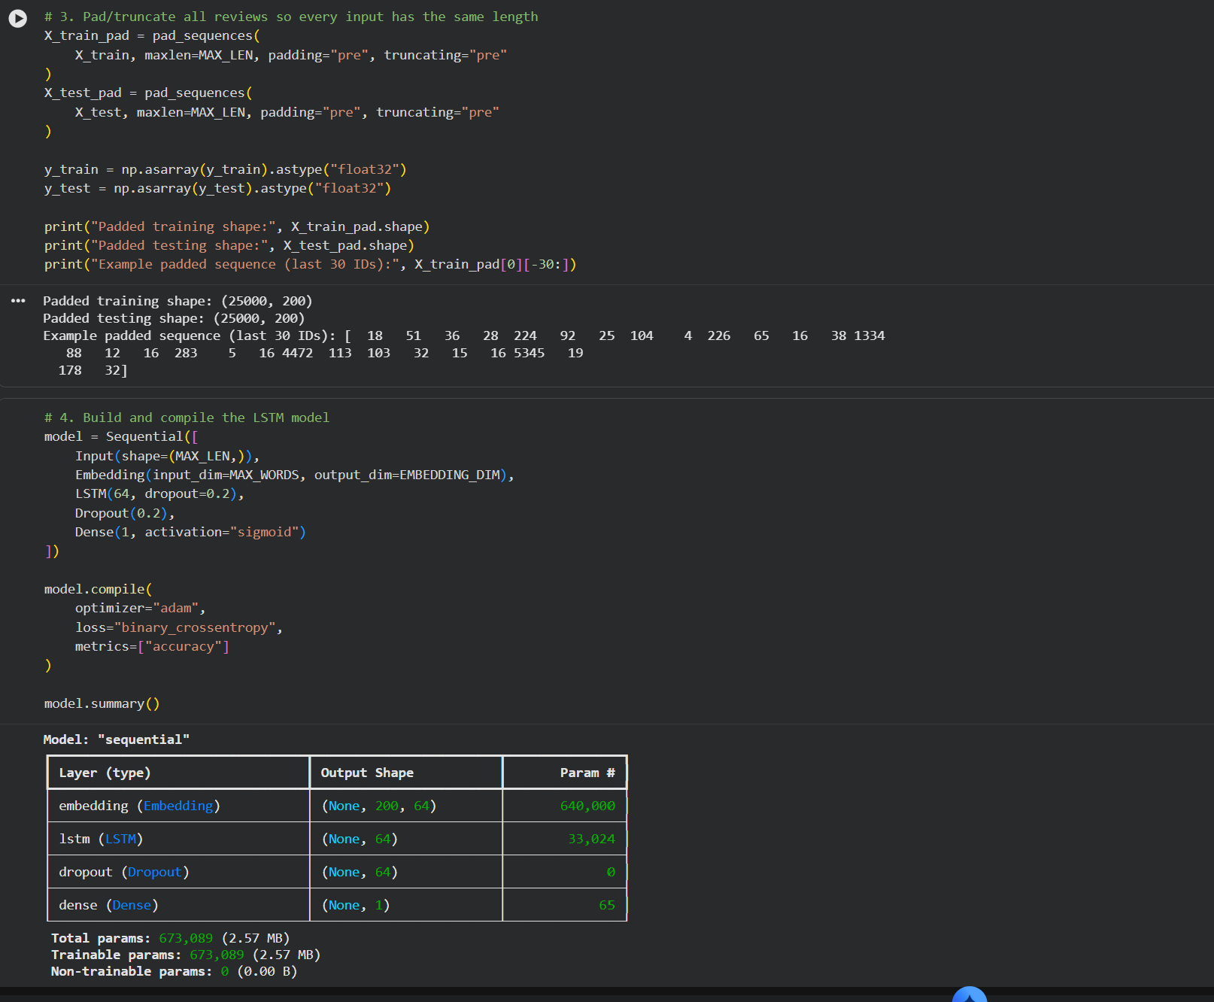

PART D: SENTIMENT PREDICTION AND DEEP LEARNING EXPERIMENT MANAGEMENT

Perform the following tasks:
- Provide new movie-review sentences as input to the trained LSTM model.
- Preprocess and tokenize the input text using the same vocabulary used during training.
- Apply sequence padding to the input text.
- Predict the sentiment using the trained LSTM model.
- Classify the input as Positive or Negative based on the predicted probability.
- Provide multiple review samples with different sentiments.
- Compare the predicted sentiment with the actual/expected sentiment.
- Analyze the coherence and correctness of the model predictions.
- Document the observations and upload the notebook to GitHub.

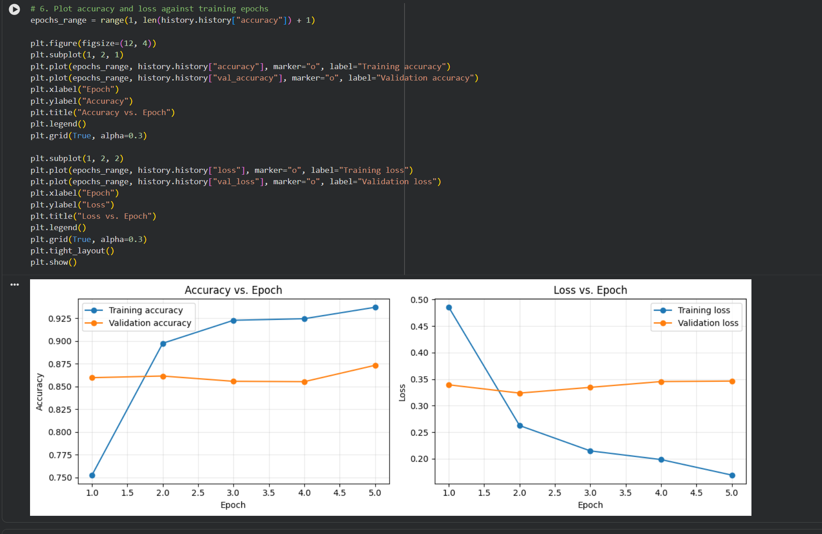

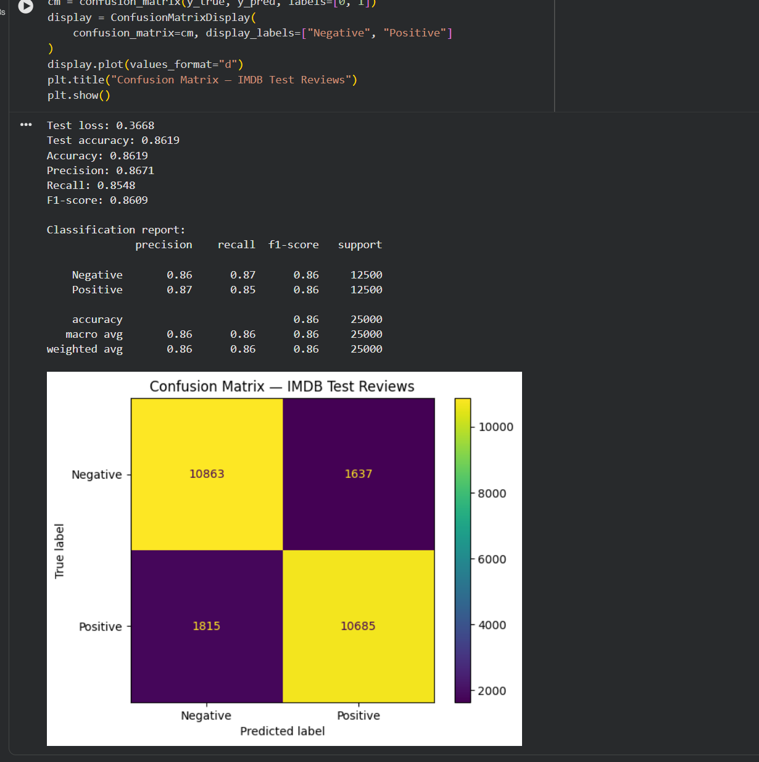

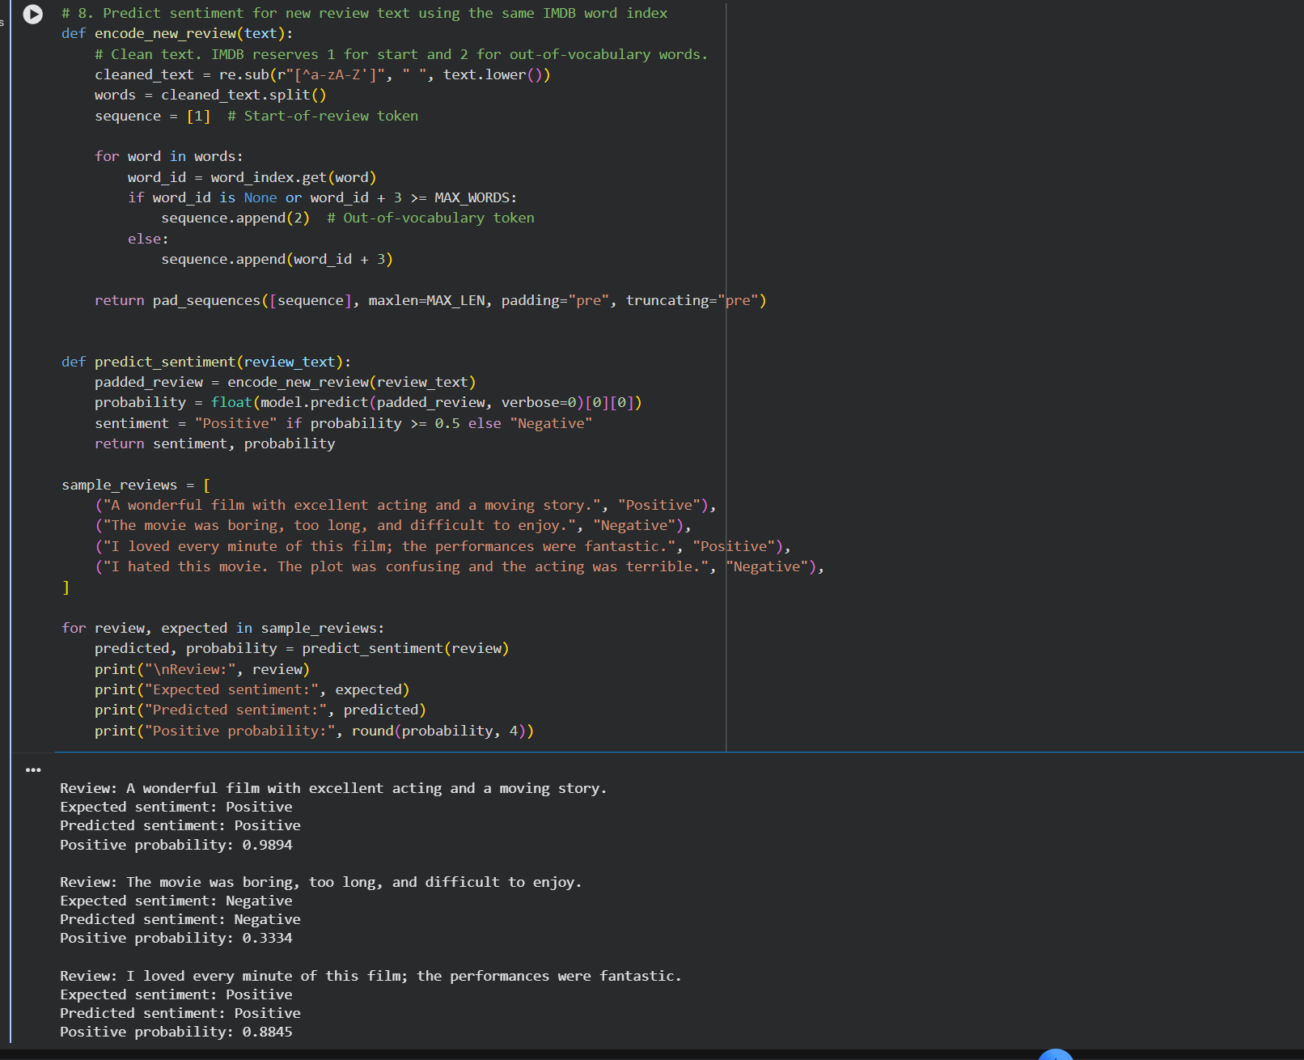

POST-LAB QUESTIONS (PROVIDE BRIEF ANSWERS TO THE FOLLOWING QUESTIONS)

- Explain how the cell state helps an LSTM retain information over long sequences.

The cell state acts as the memory of an LSTM. It carries important information across multiple time steps and helps reduce the vanishing gradient problem, allowing the network to learn long-term dependencies.

- Describe the functions of the input gate, forget gate, and output gate in an LSTM.

- Input gate: Controls what new information is stored in the cell state.
- Forget gate: Decides what old information should be removed.
- Output gate: Determines what information is passed to the next layer or time step.

- Discuss the effect of insufficient training epochs on the performance of an LSTM sentiment classification model.

Insufficient training epochs may cause underfitting. The model may not learn important patterns properly, resulting in lower training and validation accuracy.

- Explain one advantage of LSTM over a Simple RNN for sentiment analysis.

LSTM can retain important information over longer sequences more effectively than a Simple RNN. Therefore, it can better understand context in lengthy movie reviews.

- Discuss how sequence length can affect the accuracy and computational requirements of an LSTM-based sentiment analysis model.

Longer sequences may preserve more contextual information but require more memory and computation time. Shorter sequences train faster but may lose important information if the text is truncated.

ASSESSMENT
Description | Max Marks | Marks Awarded
Pre Lab Exercise | 5
In Lab Exercise | 10
Post Lab Exercise | 5
Viva | 10
Total | 30
Faculty Signature

